EE052
PRINCIPLES OF EE1 LAB

Lab 5

Frequency and
Phase Shift Measurement

Full name: ……………………………………………
Student number: …………………………………….
Class: ………………………………………………....
Date: ………………………………………………….

OBJECTIVES
After completing this experiment, you should be able to:
- Graphically represent complex number (phasor diagram).
- Use an oscilloscope to measure the frequency and phase shift of periodic waveforms.
- Calculate equivalent impedance a circuit using the oscilloscope.
- Verify theoretical relations among frequency, impedance, voltage, and current in an AC network.

INTRODUCTION
This laboratory will explore the effects of an AC source on electric circuits. With AC circuits, capacitors and inductors will prove to be more challenging than they might be in DC circuits. These capacitors and inductors are energy storage elements that behave differently depending on the frequency of the source. Therefore, an AC circuit designed for 60 Hz cannot be used in radio frequency (RF goes from 90 kHz to 110 MHz), or microwave circuits (up to 300 GHz). This concept must be clear understood in order to successfully design electronic circuits.
In AC circuits, the value of the circuit impedance can change depending on the frequency of the source. The impedance of an inductor is jωL Ω, and the impedance of a capacitor becomes (jωC)⁻¹ Ω. These values will change with ω, which is the frequency of the AC source. Thus, a circuit could go from a small impedance to a large impedance or vice versa just by changing the frequency of the input signal.
When the AC circuit has capacitors and inductors, not only the magnitude of the impedance changes but also its phase. Therefore, the impedance of an AC circuit can change from being inductive to capacitive or vice versa depending on the frequency of the source.

This laboratory will analyze the impedance change of simple AC circuits when the frequency of the power source is changed.

PRE-LABORATORY

Part A: RC Circuit and Transient Simulation

- 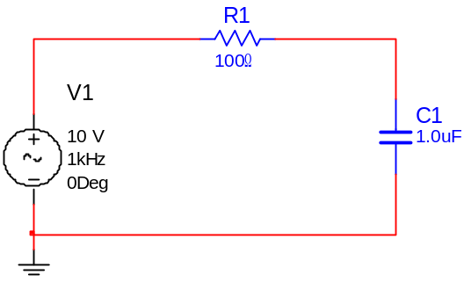
I
- Figure 1 – RC circuit
- Using any circuit analysis technique, find the voltage drop across the resistor R₁, the voltage drop across the capacitor C₁ and the mesh current I for the circuit shown in Figure 1. Complete Table 1 (see Laboratory Data Section). Note: All these values are complex number; so you must calculate amplitude and phase. Assume R₁ = 100 Ω, C₁ = 1 μF, f = 1 KHz and V₁ = 10 V.
- Draw a phasor diagram to scale showing the source voltage V₁, the voltage drop across the resistor R₁, the voltage drop across the capacitor C₁ and the mesh current calculated I of the circuit shown in Figure 1. Use the source voltage (also called input voltage) V₁ as your reference. Calculate the phase shift between the input voltage V₁ and the voltage drop across the resistor R₁. Calculate the phase shift between the input voltage V₁ and the voltage drop across the capacitor C₁.
- State module and phase of each phasor.
- Plot the waveform of current i(t) (the current in time domain)

Part B: RLC Circuit and AC Sweep Simulation
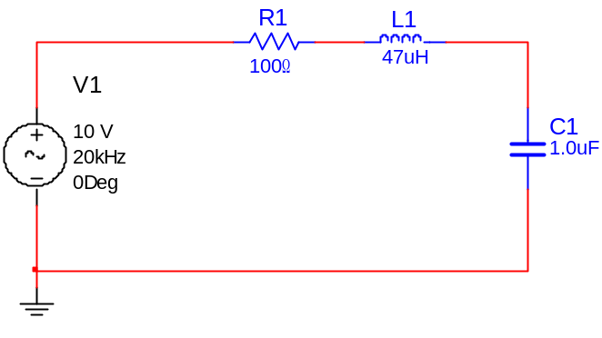
Z_{in}
Figure 2 – RLC circuit
1Vac
0Vdc

- For the circuit shown in Figure 2, do the following:
- Find the input impedance Z_{in} and determine at which frequency, ω in rad/s, |X_{L}| = |X_{C}| Ω. Do this symbolically. Do not use any specific value.
- For this value of ω when |X_{L}| = |X_{C}| Ω, what is the phase shift between the applied voltage V₁ and the loop current I₁? What does this imply?
- Using the equation obtained in part a, calculate the frequency in Hertz at which |X_{L}| = |X_{C}| Ω, assuming R₁ = 100 Ω, C₁ = 1 μF, L₁ = 47 µH.
- Using the input impedance equation obtained in 6a, and R₁ = 100 Ω, C₁ = 1 μF, L₁ = 47 µH, complete Table 2 of Laboratory Data Section.

EQUIPMENT AND PARTS LIST
      - Dual-trace oscilloscope, voltage probe and differential voltage probe.
      - Sinusoidal waveform generator.
      - 100 Ω resistor, 1 μF capacitor, 47 μH inductor.
      - Breadboard and connecting wires.

PROCEDURES

Part A: RC Circuit and Transient Simulation
The purpose of this section is the determination of the magnitude and the phase shift of several waveforms and how they relate to the results obtained during the Pre-Laboratory.
- Construct the circuit shown in Figure 1.
- Connect the voltage probe in Channel 1, and the differential voltage probe in Channel 2.
- Stimulate the circuit using a sinusoidal waveform generator set to an amplitude of 10 V peak and a frequency of 1 KHz. Connect the voltage probe (i.e., oscilloscope channel 1) across the input voltage source to make sure that the sinusoidal waveform generator is generating the desire amplitude and frequency. Next, connect the differential voltage probe (i.e., oscilloscope channel 2) across the capacitor C₁.
- Using the oscilloscope measuring features (i.e., measure menu) measure the peak-to-peak amplitude of both waveforms as well as the frequency of the input voltage V₁ (i.e., channel 1).
      - Base on the measured values, calculate the proper amplitudes taking into account any probe gain. Compare these results to the ones obtained in the Pre-Lab to make sure that they are in agreement within a reasonable error.
      - Show your instructor the waveforms, and then draw it in scale on your paper.
- Using the oscilloscope measure the time delay (or time difference) between the input voltage V₁ (i.e., channel 1) and the voltage drop across the capacitor C₁ (i.e., channel 1). Change the horizontal scale if necessary to improve the accuracy of your measurement.
      - Base on the measured values calculate the proper phase shift. Compare these results to the ones obtained in the Pre-Lab to make sure that they are in agreement within a reasonable error. Is it leading or lagging?
      - Using these values and the values obtained in 3a, determine the complex number (magnitude and phase) the represents the input voltage V₁ and the voltage drop across the capacitor C₁ and complete Table 1 (see Laboratory Data Section).
      - Show your instructor the waveforms, and then draw it on your paper.
- Using the same procedure describe in 3 measured the voltage drop across the resistor R₁. Note: Make sure of follow the entire procedure describe above including the saving of all waveforms and the completion of Table 1 in Laboratory Data Section.
- The mesh current is measured indirectly by measuring the voltage across the resistor R₁ since it can be estimated by dividing this voltage drop by the resistor value (i.e., I =V_{R1}/R₁). In addition, since the impedance presented by the resistor R₁ has no phase (i.e., the imaginary part is equal to zero), the phase of the mesh current I is equal to the mesh of the voltage drop across the resistor R1. Using the measured resistor voltage drop and the above mentioned technique calculate the mesh current and complete Table 1 in Laboratory Data Section.

Part B: RLC Circuit and AC Sweep Simulation
The purpose of this section is the determination of the input impedance Z_{in}, how it changes with respect to frequency and how it relates to the results obtained during the Pre-Lab. The input impedance Z_{in} is measured indirectly by measuring the input voltage V₁ and the mesh current I. Next, the input impedance Z_{in} is calculated using Ohms law.
- Construct the circuit shown in Figure 2. Stimulate the circuit using a sinusoidal waveform generator set to an amplitude of 10 V peak and a frequency of 20 KHz. Connect the voltage probe (i.e., oscilloscope channel 1) across the input voltage source to make sure that the sinusoidal waveform generator is generating the desire amplitude and frequency.
- Connect the differential voltage probe (i.e., oscilloscope channel 2) across the resistor R₁ and measure the voltage drop across this resistor using the measuring feature of the oscilloscope. Draw this waveform on your paper.
- Calculate the mesh current I by dividing the voltage drop across R₁ by the resistor value.
- Measured the time delay between the input voltage V₁ (i.e., channel 1) and the voltage drop across the resistor R₁ (i.e., channel 2). Change the horizontal scale, if necessary, to improve the accuracy of your measurement. Draw this waveform on your paper.
- Using this value calculate the mesh current phase shift and determine the complex number (magnitude and phase) the represents the mesh current. Complete Table 2 of the Laboratory Data Section.
- Repeat the entire process above for the different frequencies give in Table 2 (i.e., 21, 22, 23, 24, 25 KHz). Note: Make sure of follow the entire procedure describe above including the saving of all waveforms.
- Measure the frequency in Hertz at which |X_{L}| = |X_{C}| Ω by adjusting the frequency of the sinusoidal waveform generator until the input voltage V₁ and the voltage drop across the resistor R₁ are in phase. Write these values, and draw this waveform on your paper.

POST - LABORATORY
The lab report is a written document where you compare your calculation and simulation results obtained in the Pre-Laboratory section with the measurements taken during the Laboratory section. This document must contain your theoretical calculations, your simulation results and your measurements.

Part A: RC Circuit and Transient Simulation
Compare the measurements obtained during the lab for the RC circuit with the theoretical analysis and the calculation results obtained during the Pre-Laboratory section. Make sure of explaining any possible differences and what might be their causes.

Part B: RLC Circuit and AC Sweep Simulation
Compare the measurements obtained during the lab for the LRC circuit with the theoretical analysis and the simulation results obtained during the Pre-Laboratory section. Make sure of explaining the following points:
- Did the input impedance Z_{in} change in any way from the lower frequency to the higher frequency (i.e., magnitude and phase)? How could this impedance be viewed at 20 KHz and 25 KHz?
- Is there a point where |X_{L}| = |X_{C}|? If so, at which frequency? Compare this frequency with the one obtained analytically and using simulation. Explain any possible differences and what might be their cause.
- Compare the calculated, simulated and measured input impedance. Explain any possible differences and what might be their cause.
Finally, draw a general laboratory conclusion based in your theoretical analysis, simulations and comparison of calculated, simulated and measured values.

Laboratory Data Section

Table 1: RC Circuit and Transient Simulation
Variable | Calculations |  | Measurements
Variable | Magnitude [V] | Phase [deg] | Magnitude [V] | Phase [deg]
V₁
V_{C1}
V_{R1}
I | [A] |  | [A]

Table 2: RLC Circuit and AC Sweep Simulation
Frequency  [KHz] | Calculations |  | Measurements
Frequency  [KHz] | Magnitude [Ω] | Phase [deg] | Magnitude [Ω] | Phase [deg]
1
10
22
40
100
140

Useful equations:
